**Assisted Practice: 3.4 Create an EBS Volume**

**Step 3.4.1:** Selecting the **volume** tab in the EC2 dashboard

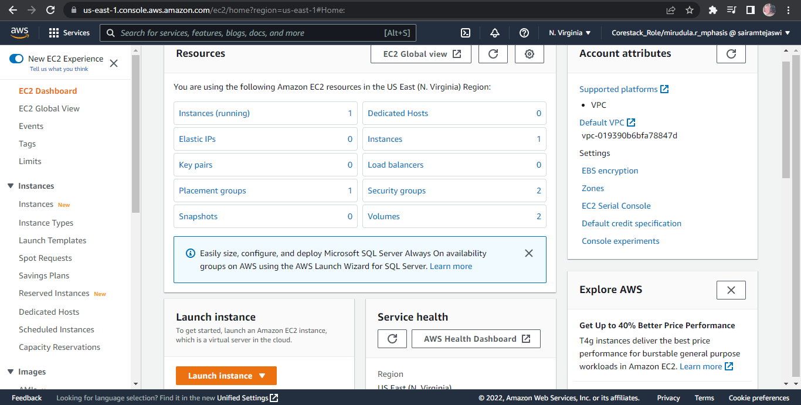

**Step 3.4.2:** Creating a new volume by clicking on **Create**

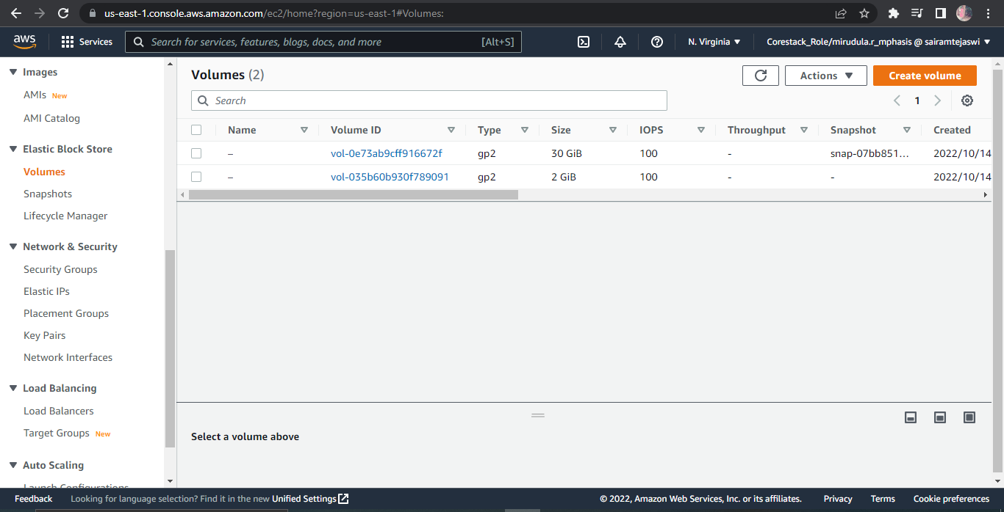

**Step 3.4.3:** Selecting the volume type according to the project requirement

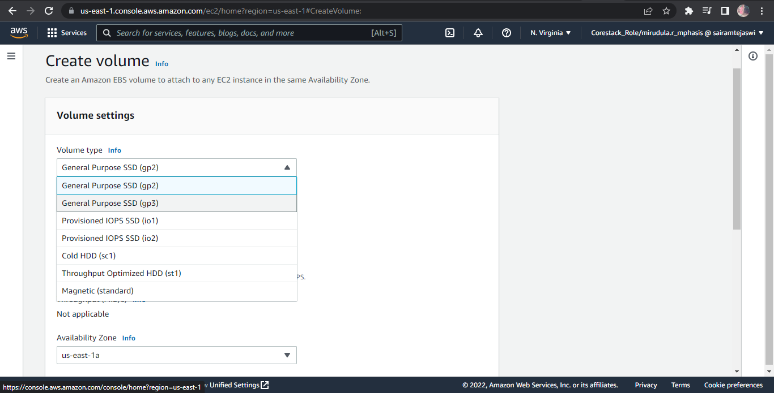

**Step 3.4.4:** Creating a new volume by specifying the size and defining the zone

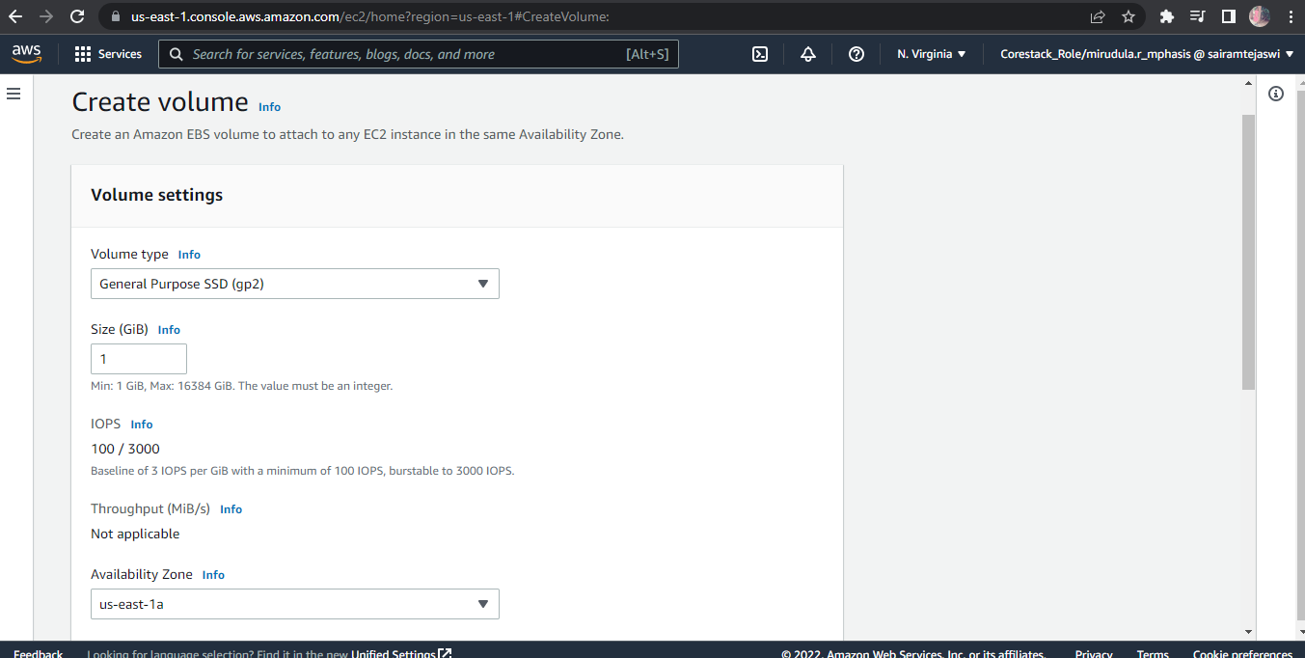

**Step 3.4.5:** Verifying the new volume created on the volume console and its availability

